PREREQUISITES

Software-Latest version of python

Team ID : PNT2022TMID47453

IBM ID : **IBM-Project-6890-1664363413**

Python IDE:

Python integrated development environments, or Python IDEs, are software

platforms that provide programmers and developers with a comprehensive set of tools for software development in a single product, specifically in the Python programming language.

IDE stands for Integrated Development Environment. It's a coding tool which

allows you to write, test, and debug your code in an easier way, as they typically offer code completion or code insight by highlighting, resource management, debugging tools.

Install and setup the Python IDE

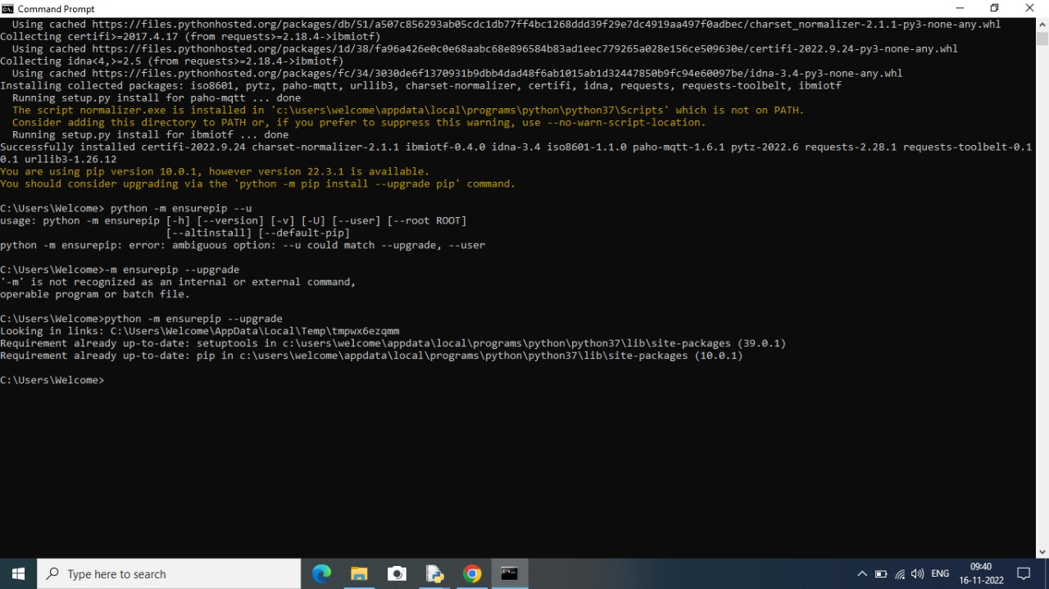

WATSON IOT PYTHON SDK INSTALLATION:

